**Webpack Config Changes into PCF Scripts**

**Step 1**

Resolve the CSS loader error issue into webpack config of pcf-scripts node package.

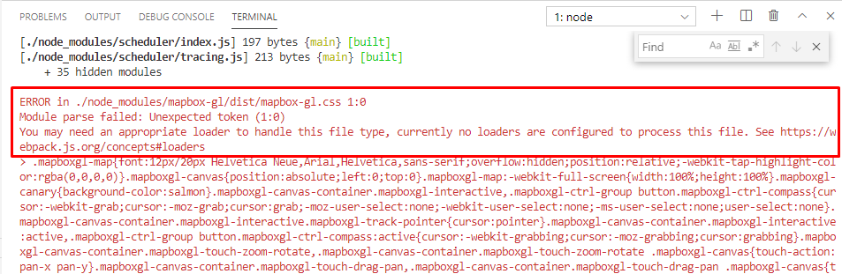

**Step 1.1** Add below lines into *node_modules/pcf-scripts/webpackConfig.js* file

{

test: /\.css$/i,

    use: ['style-loader', 'css-loader'],

},

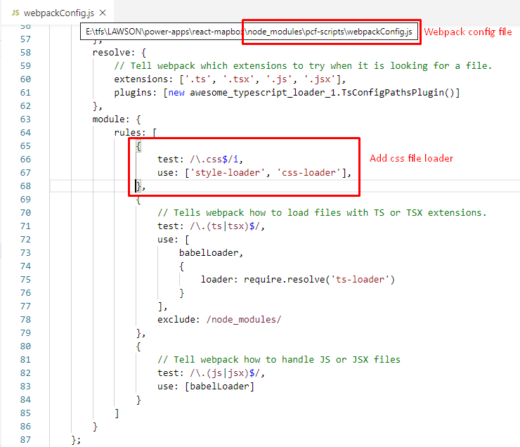

**Step 1.2** Install two dependencies in our application

* npm install --save css-loader
* npm install --save style-loader

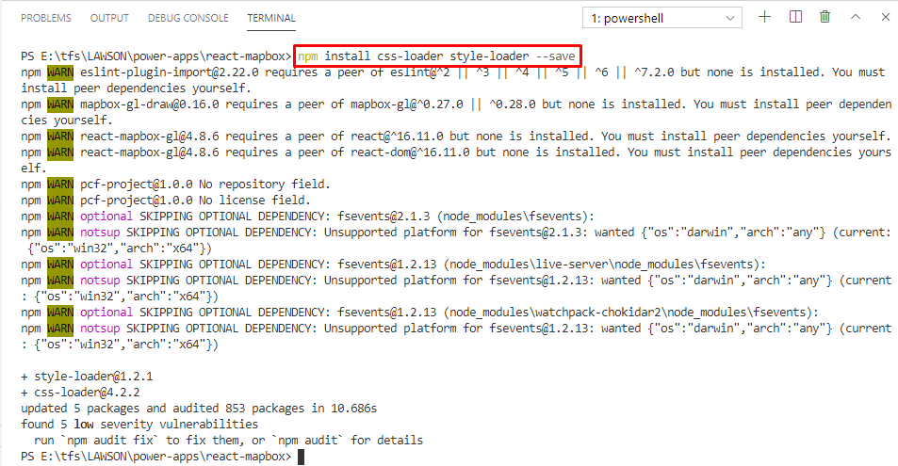

Added these 2 dependencies in the package.json file after installation completed successfully.

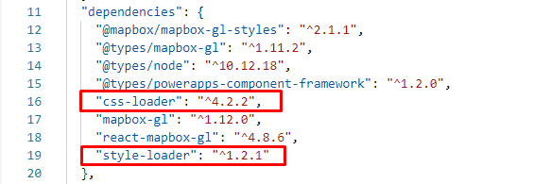

**Step 2**

Resolve the **fs** module not found error issue into webpack config of pcf-scripts node package.

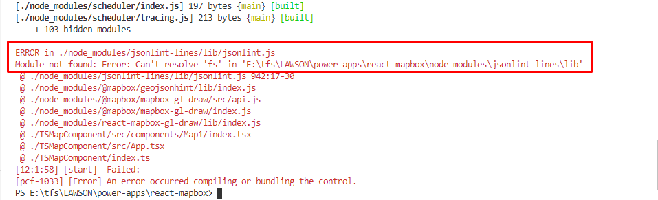

Add below lines into *node_modules/pcf-scripts/webpackConfig.js* file

node: {

  fs: "empty"

},

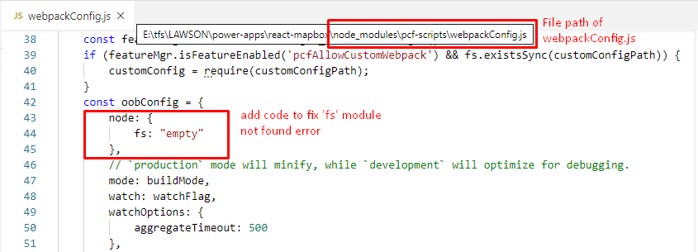

**Step 3**

Resolve the **image loading** error issue into webpack config of pcf-scripts node package.

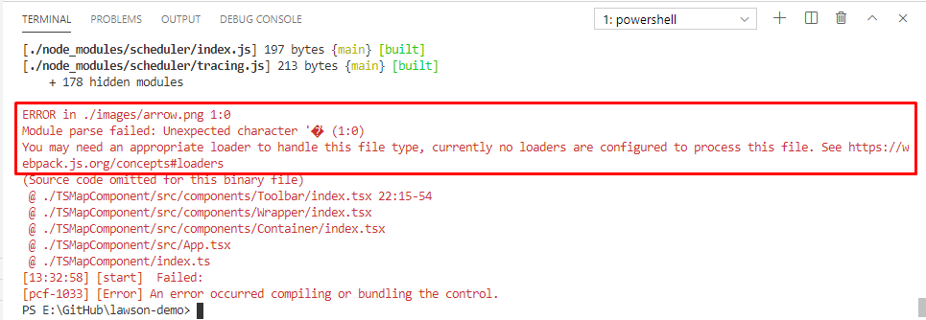

**Step 3.1** Add below lines into *node_modules/pcf-scripts/webpackConfig.js* file

{

    test: /\.(jpe?g|png|gif|svg)$/i,

    use: [{

        loader: 'url-loader',

        options: {}

    }]

},

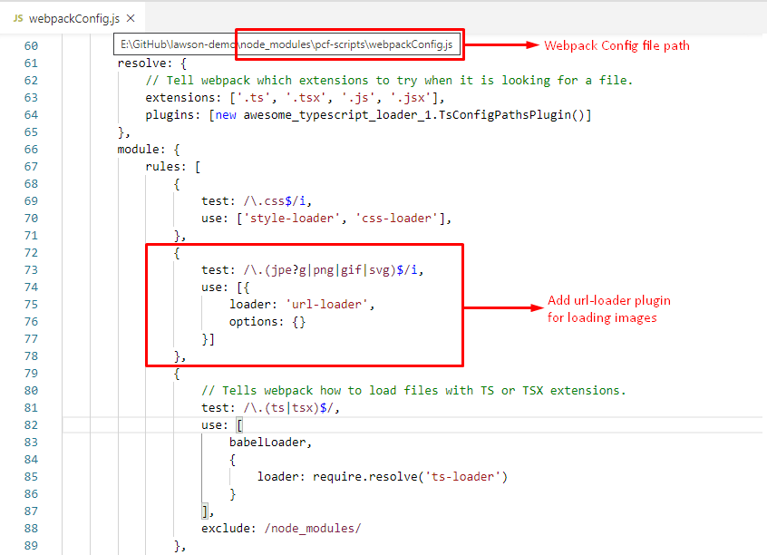

**Step 3.2** Install below dependency in our application

* npm install url-loader --save

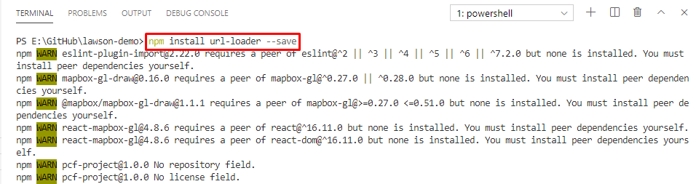

Added this dependency in the package.json file after installation completed successfully.

